**Instructions –2025 Best Practices Inventory Online Platform**

# Accessing the Best Practices Inventory

Step One: Click on <https://fast.dca.nj.gov>to enter the Best Practices (BPI) Platform’s sign-in page.  Although the BPI Platform will function in all widely-used internet browsers, Google Chrome is recommended.

Step Two: At the sign-in page, the municipal Chief Finance Officer (CFO) will use their Financial Automation Submission Tracking solution (FAST) log-in to enter the BPI platform. After entering the log-in credentials click the **Sign-In** button to reach the Portal Home page.

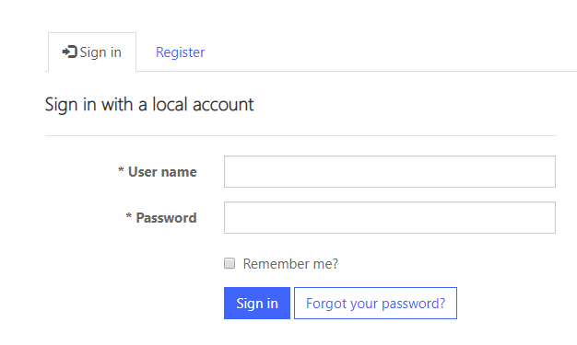

* CFOs that do not possess FAST log-in credentials must select FAST from the navigation bar on the top right of the screen, then follow the process in the [FAST Portal Registration Guide](https://www.nj.gov/dca/divisions/dlgs/pdf/NJ%20DCA%20FAST%20Portal%20Registration%20Guide.pdf)for obtaining access to FAST.  After obtaining FAST log-in credentials, the CFO must request BPI access separately.

Step Three: Upon reaching the Portal Home page, click BPI on the top of the navigation bar in the upper right-hand corner.

Once the BPI selection is clicked and you reach the BPI Homepage, Best Practices Inventories for municipalities associated with the CFO’s current log-in will be listed under the Local Government Entity heading.

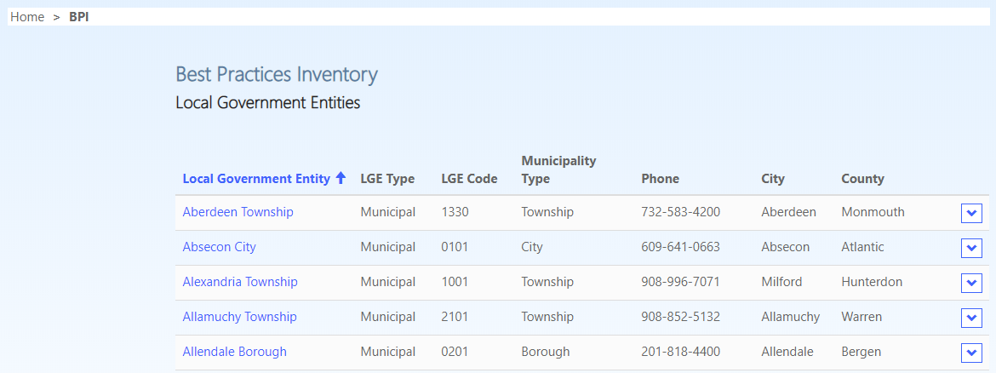

Step Four: Once logged in, under the Local Government Entity heading on the BPI Homepage, click the municipality for which you will be completing a Best Practices Inventory.

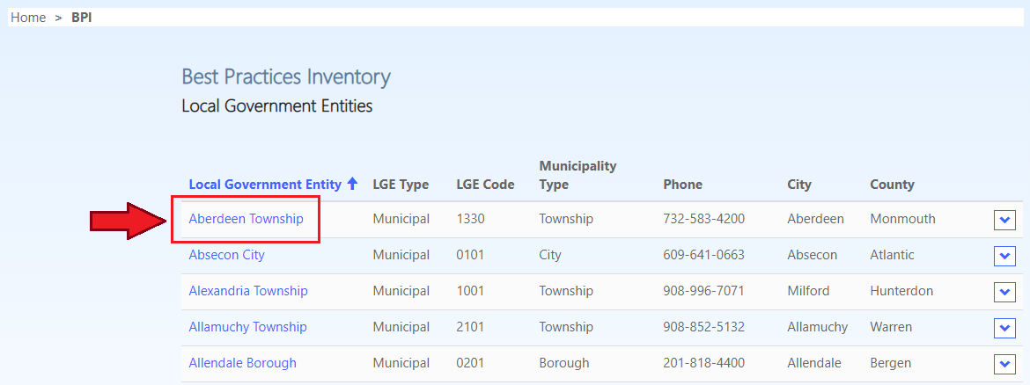

Step Five: For each municipality, the CFO must click on the Roster of Officials tab on the upper left-hand corner, enter the name of the municipality’s Chief Administrative Officer (CAO) and Municipal Clerk, and then click the Updated Officials button on the bottom.

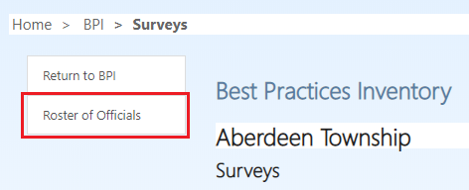

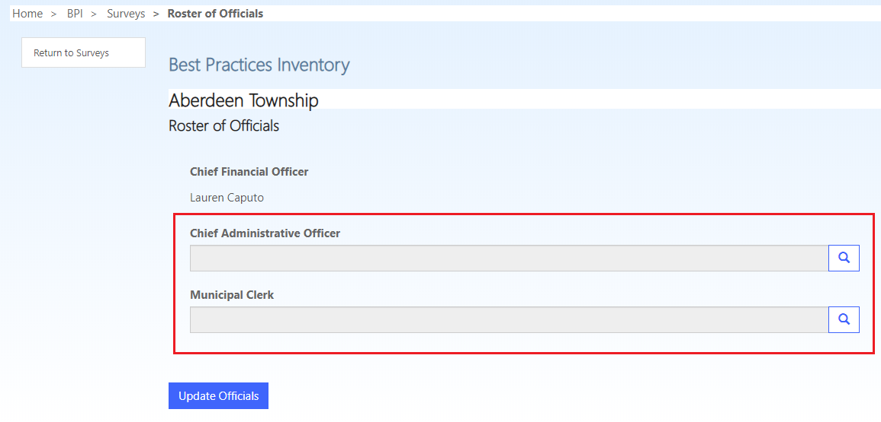

Step Six: The CAO and Municipal Clerk must obtain their own log-in credentials by clicking on the Register tab and then selecting Request Access, unless they already have FAST log-in credentials.

*Registration page:*

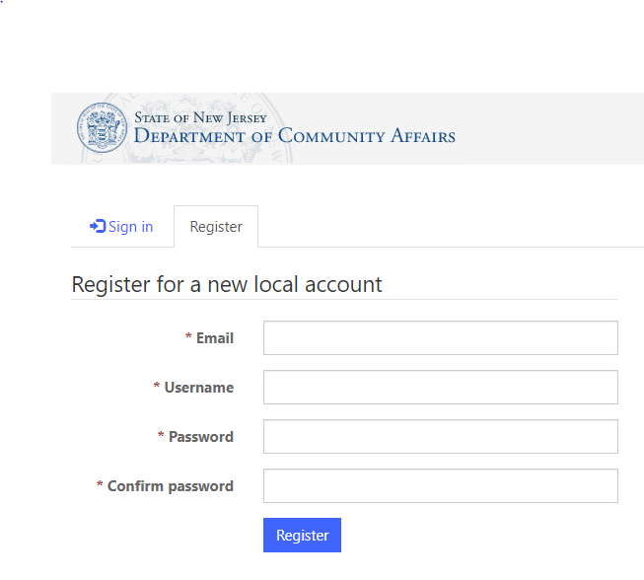

*Request Access page:*

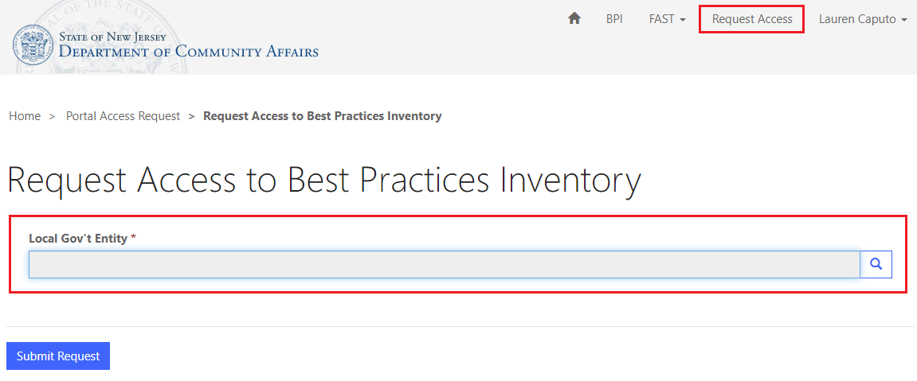

Individuals holding multiple titles must have an individual log-in credential corresponding to each position; for example, if the CFO is also a Business Administrator in the same municipality, the CFO must type their own name into the Chief Administrative Officer box.

Once logged in, the CAO and Municipal Clerk will see their associated municipalities under the Local Government Entity heading and will have the same ability as the CFO to complete the Inventory.  The CFO, CAO, and Municipal Clerk may be logged into the same Best Practices Inventory at the same time.

**Note:** **The Chief Administrative Officer is the individual, whatever their title, charged with running the municipality’s day-to-day operations.  A municipality that does not have a business administrator or municipal manager still has one individual responsible for running day-to-day operations, whether it be someone such as a CMFO, Municipal Clerk, or a Mayor.**

Forgetting Username or Password: Click the “Forgot Your Password” link located on the sign-in screen. If you forgot your username, contact the DCA Help Desk at [helpdesk@dca.nj.gov](mailto:helpdesk@dca.nj.gov).

Logging Out: Click your name at the top right corner, scroll to the bottom and click Sign Out.

**Troubleshooting Note 1**:**For those returning CAO's or Municipal Clerks, or newcomers who already possess an account.  If you do not see BPI in your Navigation Menu, or if you cannot find your municipality in the list of Local Government Entities, you will need to **Request Access**.  
 **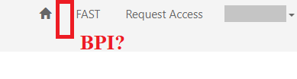    
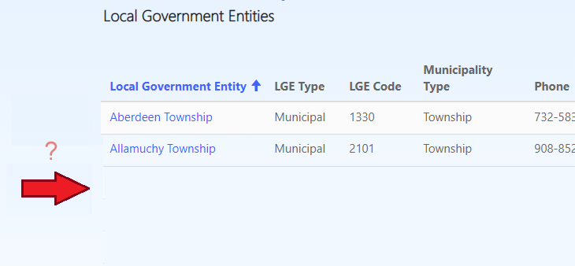  
Troubleshooting Note 2**:**For those returning CAO's or Municipal Clerks, or newcomers who already possess an account. If you attempt to access your municipality's questionnaire and you receive an access denied, you will need to have your account added to the list of permitted users by the CFO (please see Step 5)

# Completing the Best Practices Inventory

1. Under the Surveys page for your municipality, select your municipality from under the Active Surveys heading to reach the Survey View page, which will contain your municipality’s Best Practices Inventory.  As you scroll down, you can return to the top by clicking the arrow button on the bottom right corner of the screen.

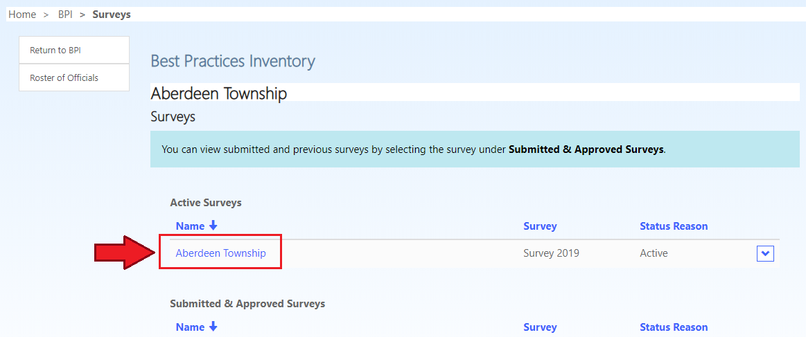

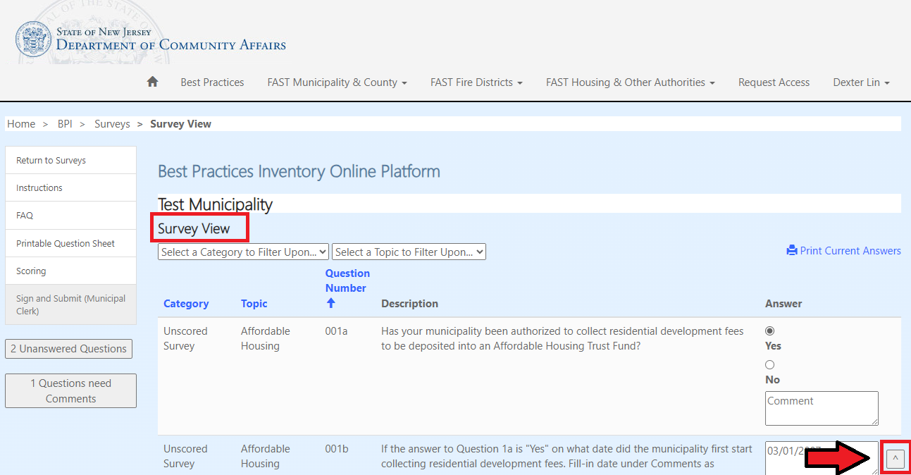 There is a total of 69 questions on the Inventory, divided by category and topic:

Category  
Core Competencies (1 point)  
Best Practices (1/2 point)  
Unscored Survey (0 points)

For Core Competencies questions, positive credit is awarded for “Yes” answers as well as “Prospective” and “N/A” responses when permitted by the question. “Prospective” is not a permitted answer for questions in the Best Practices category.

1. To print a list of all questions with the entire range of permissible answers for each questions, select the Printable Question Sheet Button from the left menu.  Hit the Ctrl and P buttons on your keyboard at the same time to open the Print Dialog Box.  To return to the question sheet, click the Return to Question List button on the left.

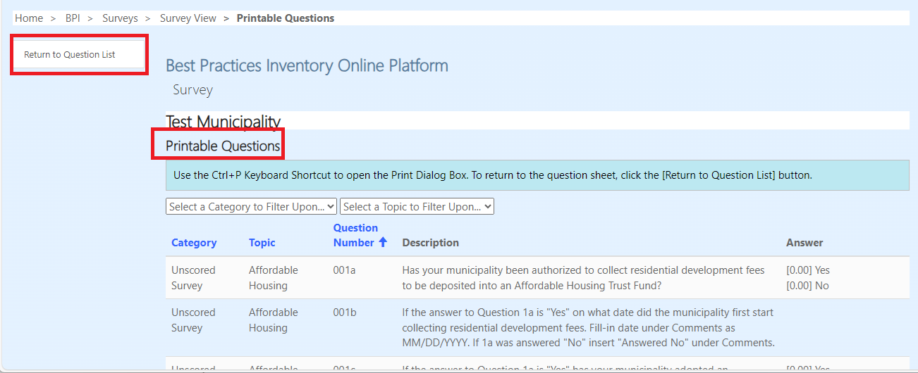

1. To answer each question, the answer column is on the right side.  Answer each question using the featured radio buttons (for Single Select questions), checkboxes (for Multiple Selection Questions).  Answers will be saved automatically when a selection is made.    
     
   **Single Select:**  
   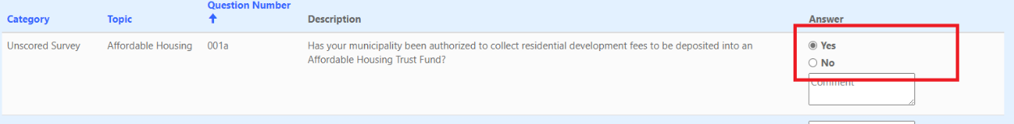  
     
   **Multiple Selection:**  
   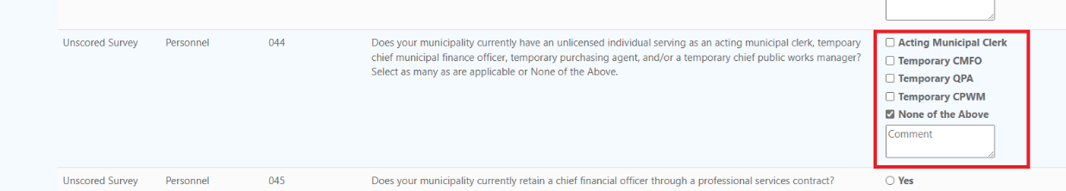

Comments are permitted for every question, but some require entry of a comment in the Comment Box to count as a complete answer.  These will be indicated with a "Comment (Required)" placeholder text in the comment box.  Clicking on a Comment box, required or not, will bring up a dialog window where your comment can be added. Comments are not autosaved, you will need to click the “Save” button to save your comment.

*Comment Required:*  


*Comment Dialog Box:*

1. All questions must be answered before the Inventory can be certified and submitted.

Buttons on the left side of the screen show the number of unanswered questions remaining*, as well as the number of remaining questions that require comments.  As questions are answered these numbers will update accordingly (there may be a momentary delay).  Clicking these buttons will highlight in the Answer column which questions are unanswered or require comments.

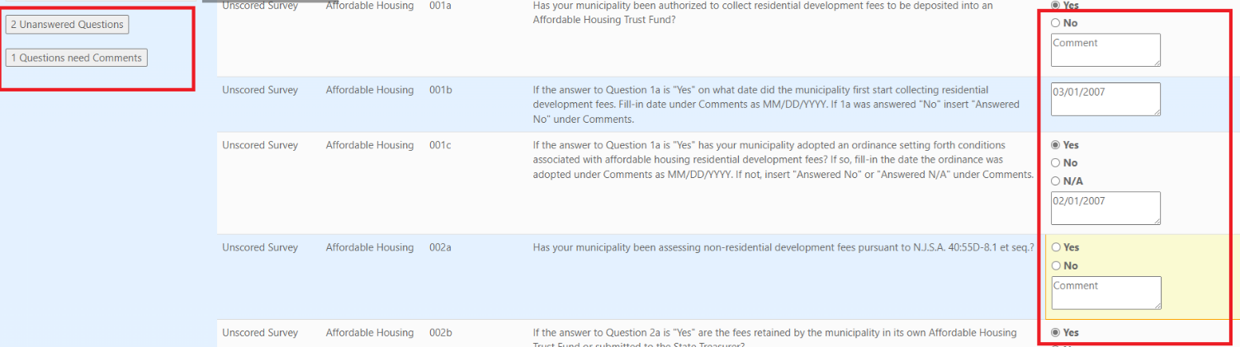

1. Score: As questions are answered, the current score can be displayed by selecting the Scoring button on the left side of the screen. The 2024 Best Practices Inventory scoring criteria is as follows:

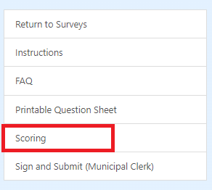 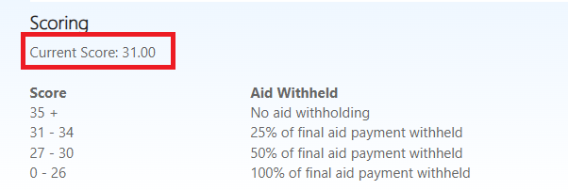

|  |  |  |
| --- | --- | --- |
| **Inventory Score** | **Final Payment Amount Disbursed** | **Impact on final 5% aid Payment** |
| 32 and greater | 100% | No withholding |
| 28-31 | 75% | Lose 25% of final formula aid payment |
| 24-27 | 50% | Lose 50% of final formula aid payment |
| 0-26 | 0% | Lose 100% of final formula aid payment |

1. Sorting and Filtering: Questions can be sorted and/or filtered by category or topic.  These sorting and filtering capabilities are also available on the Printable Question Sheet.

Sorting:

Questions can be sorted by category, topic, or question number by clicking on the blue Category, Topic, or Question Number links.

Filtering:

To filter by category: Click the “Select a Category to Filter Upon” drop down box.

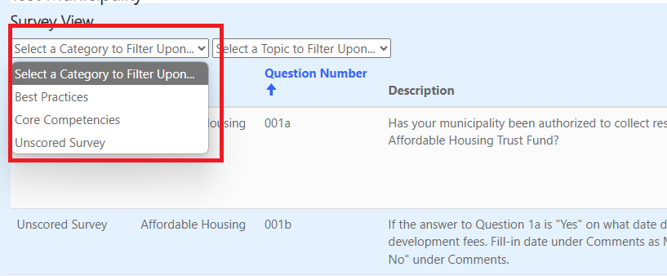

To filter by topic: Click the “Select a Topic to Filter Upon” drop down box.

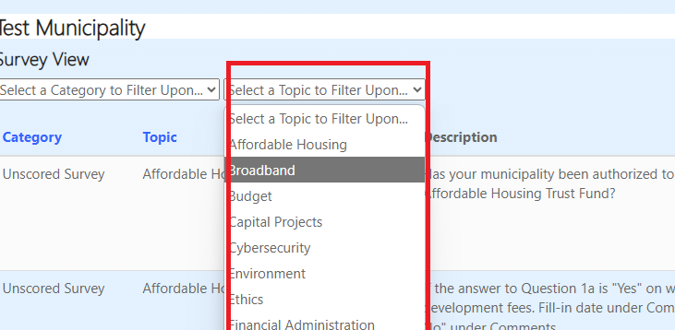

To remove filters: Click “Remove Filters” to the right of the “Select a Topic to Filter Upon” drop down box.

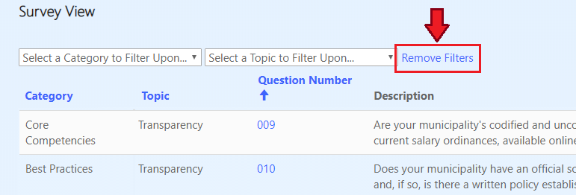

1. To print all saved answers and comments, click the Print Current Answers icon on the upper right of the screen.  Hit the Ctrl and P buttons on your keyboard at the same time to open the Print Dialog Box.  To return to the question sheet, click the Return to Question List button on the left.

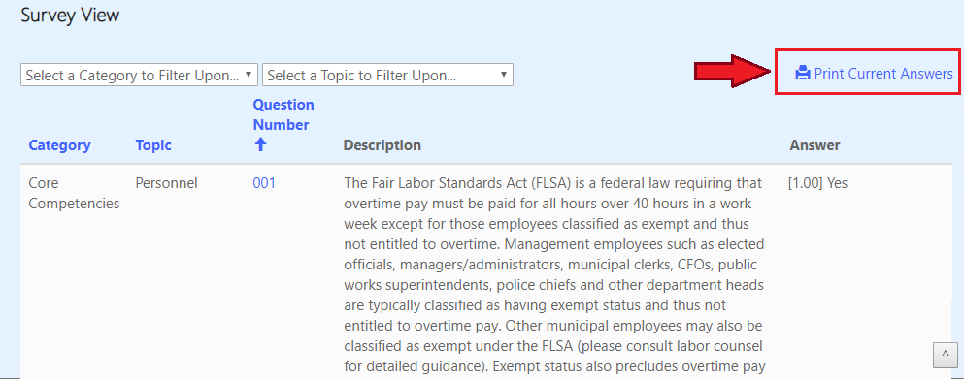

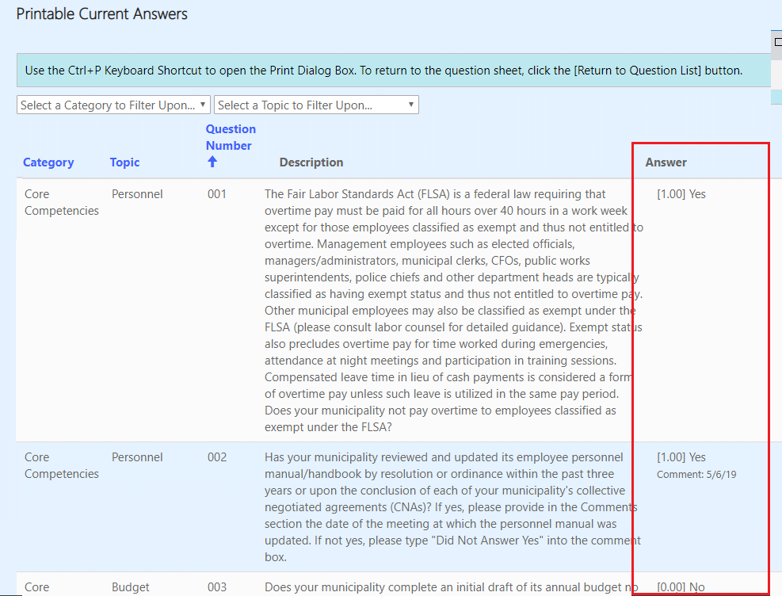

# Submitting the Best Practices Inventory

1. Once all questions are answered (including any required comments), the Sign and Submit buttons for the CFO, CAO and Municipal Clerk on the left will be enabled.

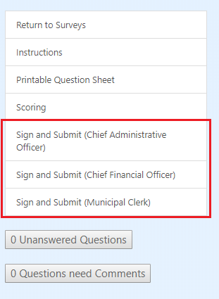

2. Before the "Submit Completed Survey" button is enabled on the bottom of the screen, the CFO, CAO, and Municipal Clerk must complete their respective certifications.  Each can see if the other two individuals have or have not yet certified.

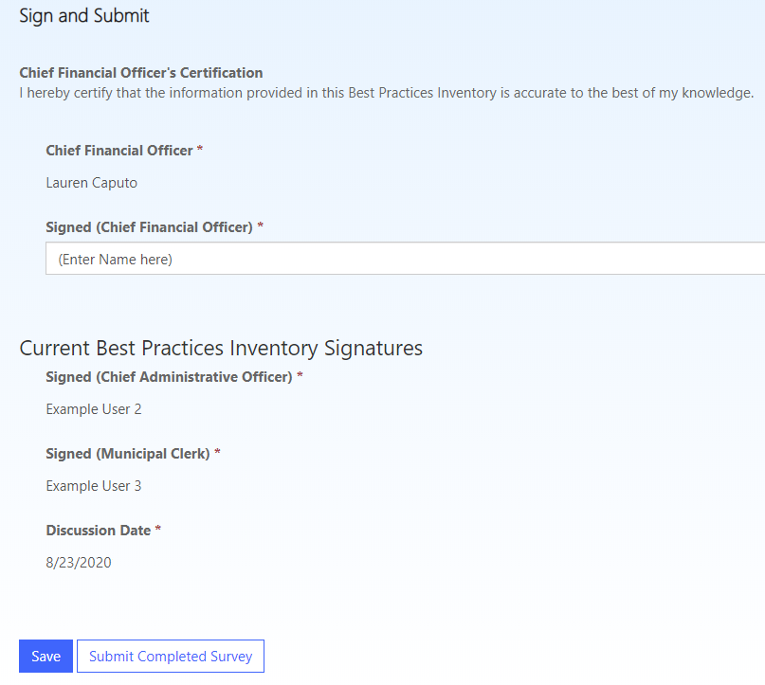

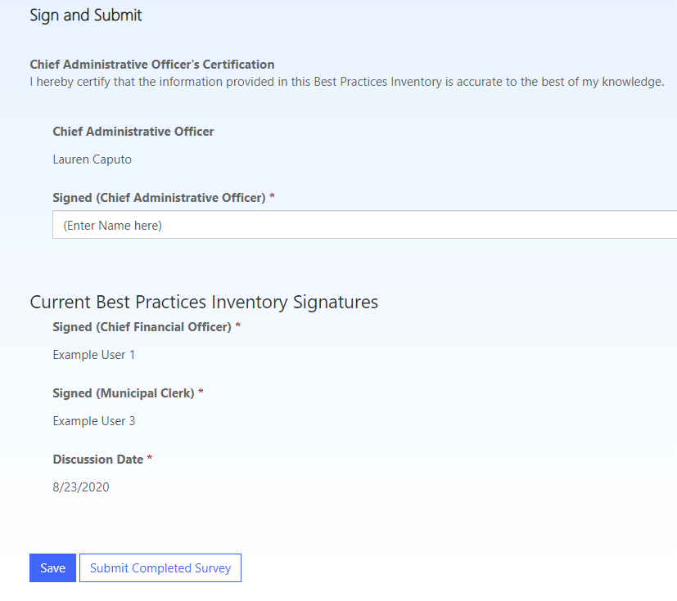

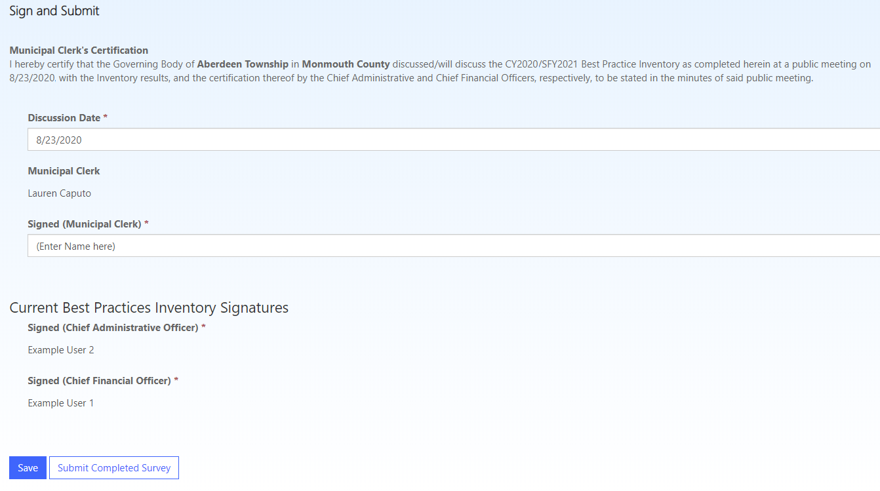

The CFO, CAO, and the Municipal Clerk must individually certify to the accuracy of the Inventory answers, and the Municipal Clerk must also certify that the Inventory either has been discussed at a governing body meeting (inserting the meeting date) or will be discussed at a governing body meeting in the near future (inserting the projected meeting date).

Once the certifications are complete, click the Submit Completed Inventory button on the bottom of the screen.  A confirmation email will be sent to the CFO, CAO, and Municipal Clerk.

3. The Best Practices Inventory cannot be changed once submitted.  All submitted Inventories associated with the CFO, CAO, or Municipal Clerk appear under Submitted and Improved Inventories on the Surveys page, which when clicked are read-only.

# Help Desk Assistance

Please email Matt Gallello at [Matthew.Gallello@dca.nj.gov](mailto:Matthew.Gallello@dca.nj.gov) if you require assistance.

## Keyboard Shortcuts:

| ***Actions*** | ***Keys*** |
| --- | --- |
| **Back (Previous Page)** | Alt + Left Arrow |
| **Forward (Next Page)** | Alt + Right Arrow |
| **Navigate through tabs** | Ctrl + Tab(Nav Right), Ctrl + Shift + Tab(Nav Left) |
| **Move down a page** | Spacebar |
| **New Tab** | Ctrl + t |
| **Increase Zoom** | Ctrl + + |
| **Decrease Zoom** | Ctrl + - |
| **Reset Zoom** | Ctrl + 0 |
| **Print** | Ctrl + p |
| **Page Refresh** | F5, Ctrl + r |
| **Find** | Ctrl + f |
| **Select all** | Ctrl + a |
| **Copy** | Ctrl + c |
| **Paste** | Ctrl + v |
| **Cut** | Ctrl + x |
| **Search Web** | Ctrl + e |

Contents

Accessing the Best Practices Inventory 1

Completing the Best Practices Inventory 5

Submitting the Best Practices Inventory 11

Help Desk Assistance 13